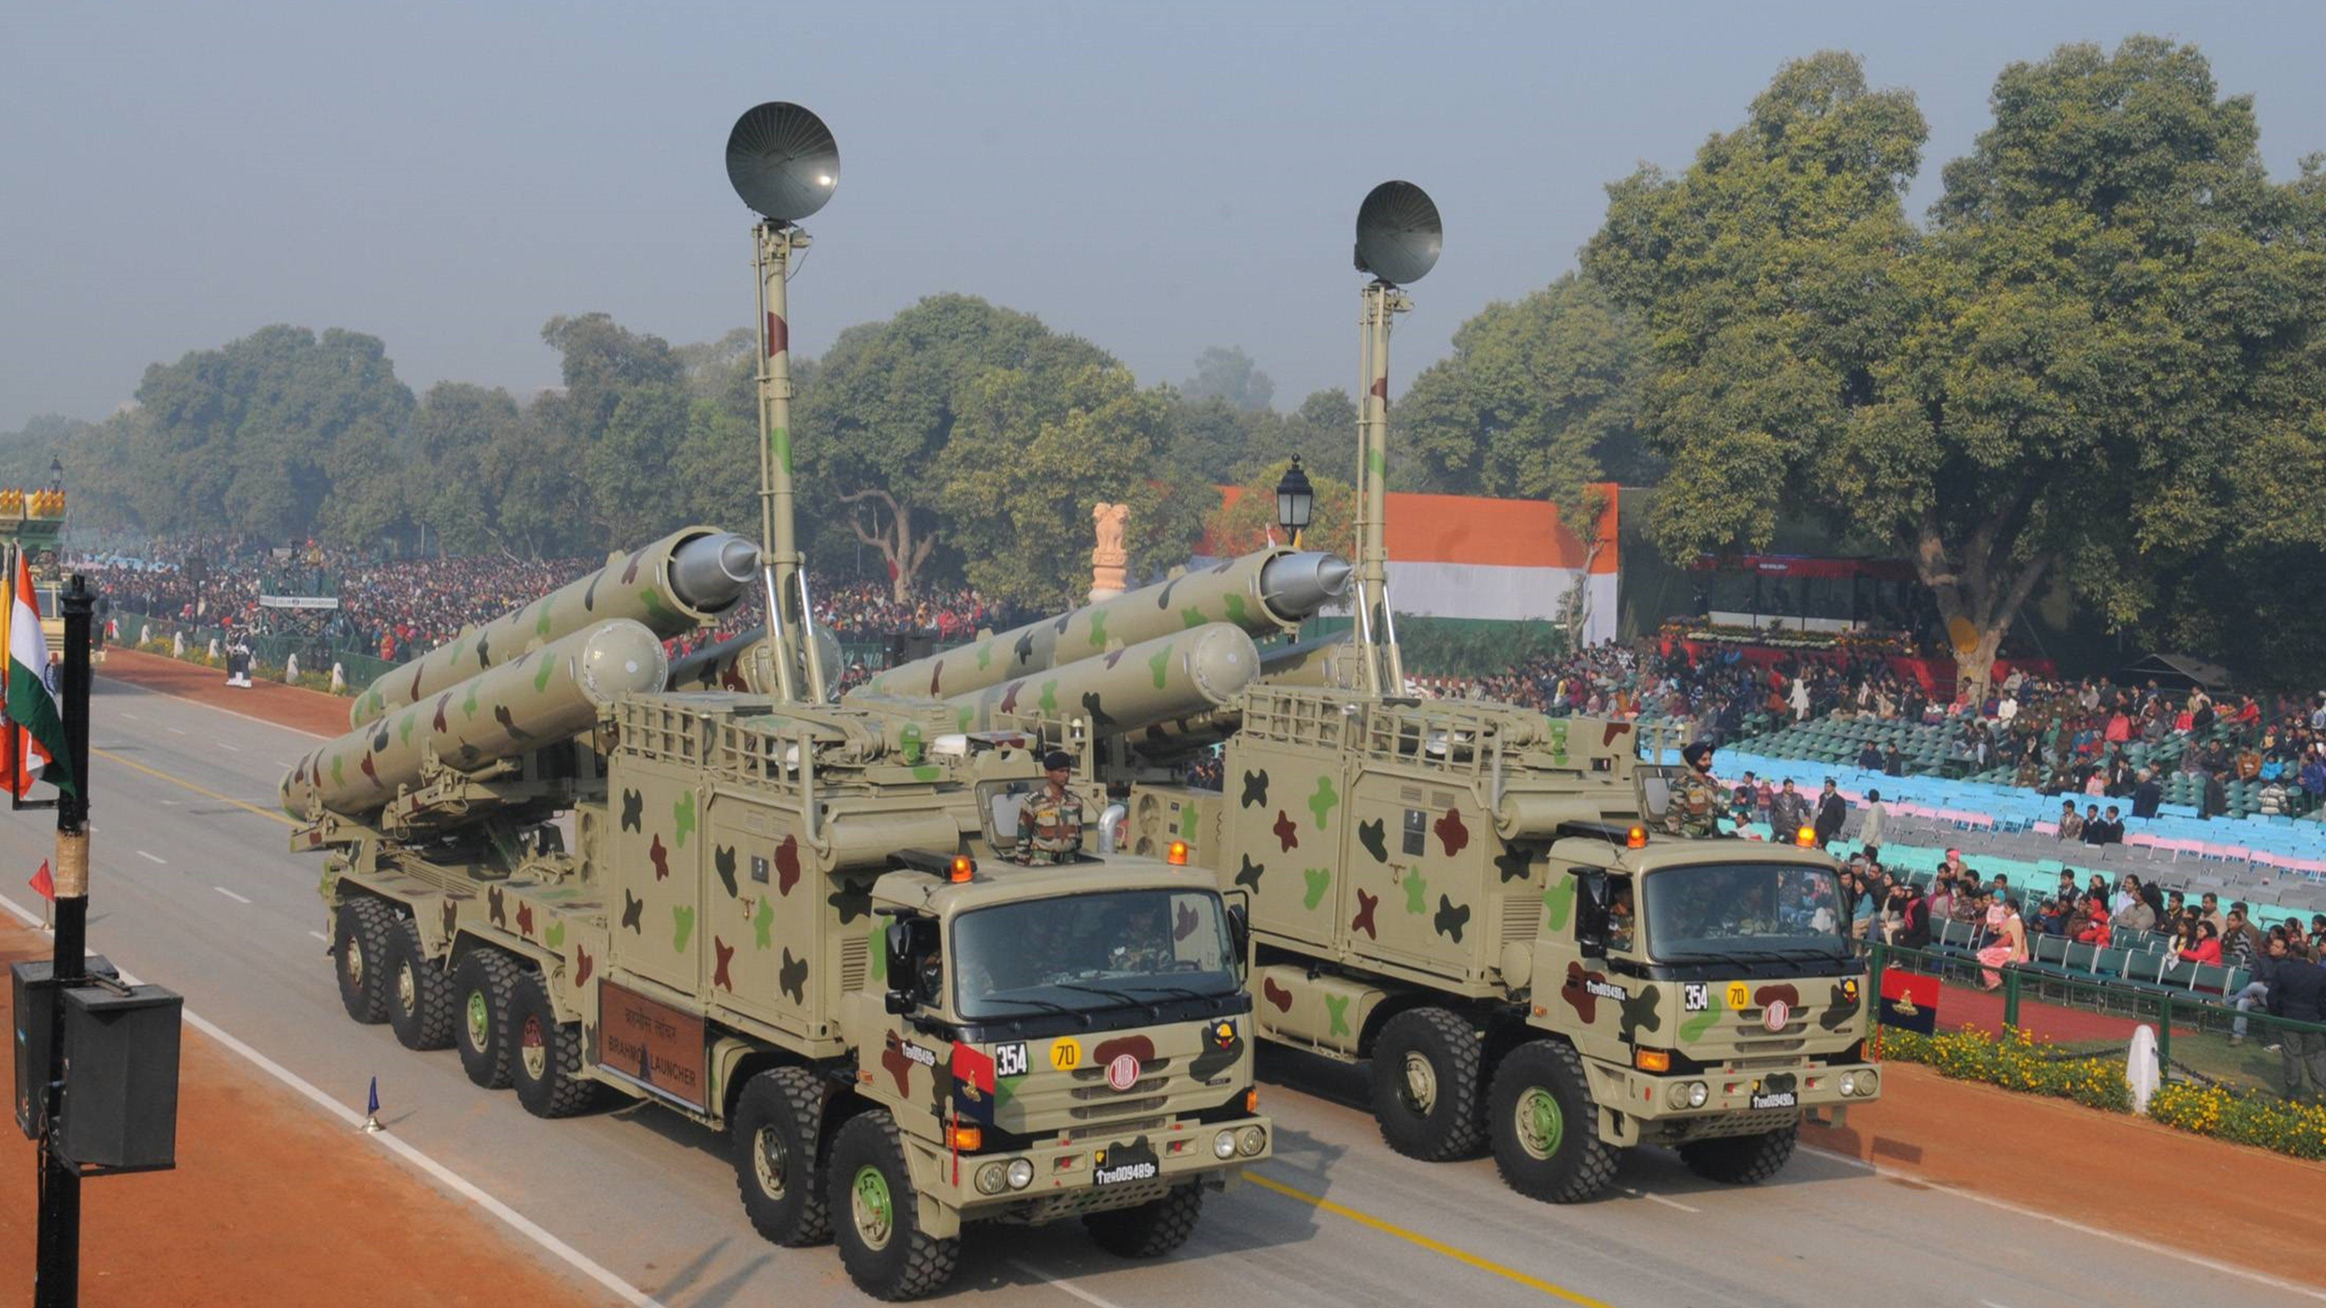

|  |
| --- |
| MOD |

|  |  |  |
| --- | --- | --- |
|  |  |  |
| Prince Kakkad – 92210133013  Harshil Bhatt – 92219133007  Brijesh Patel - 92210133014 |  |  |

# INtroduction

The Ministry of Defence is for implementing the defence policy and strategy of India. It is one of the largest ministries in the Indian government, with a focus on providing military forces and equipment to protect the country's security and interests. The Ministry of Defence is headed by the Defence Minister, who is a member of the Cabinet, and is responsible for overall policy direction and management of the armed forces. The ministry plays a vital role in ensuring the safety and security of the nation, as well as supporting international peacekeeping and humanitarian efforts. This report aims to provide an overview of the Ministry of Defence of India, its functions, structure, and challenges.

# Features

1. Homepage with an introduction to the Ministry of Defence of India and its functions.
2. Navigation menu with links to different sections of the website, such as About Us, Our Mission, Structure, Challenges, and News.
3. A section on the history of the Ministry of Defence of India.
4. Information on the different branches of the Indian Armed Forces and their roles.
5. Interactive graphics or maps displaying India's defense capabilities, military strength, and strategic alliances.
6. Detailed profiles of key leaders in the Ministry of Defence and the armed forces.
7. News section with updates on current events and developments related to the Ministry of Defence of India.
8. Links to relevant external resources, such as official government reports and policy documents.

# images of website

* HOME PAGE

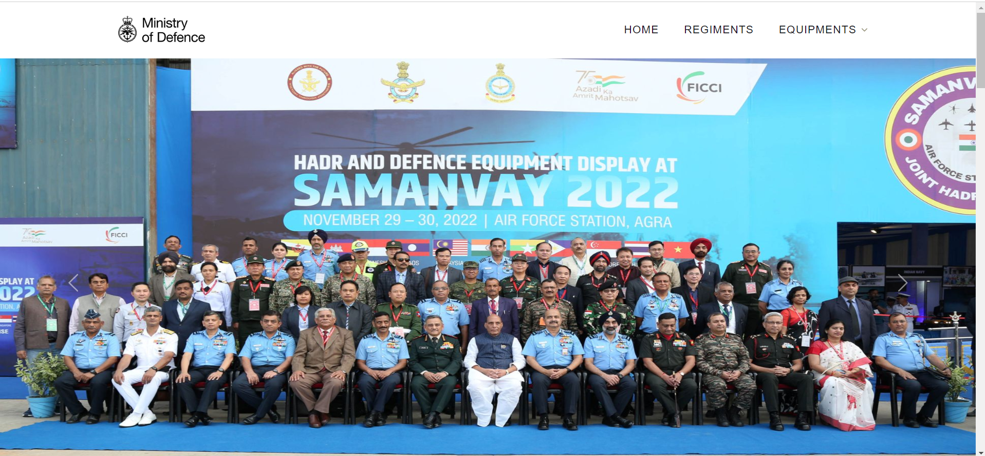

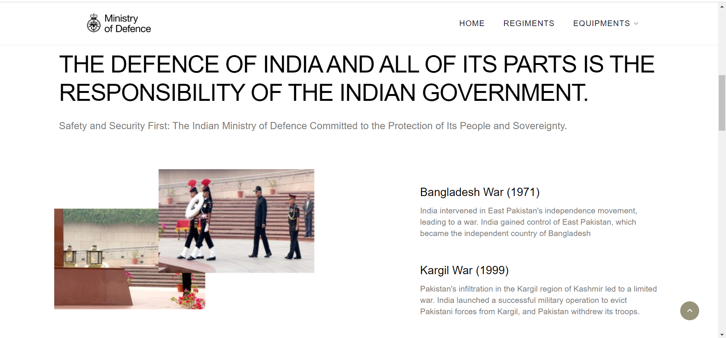

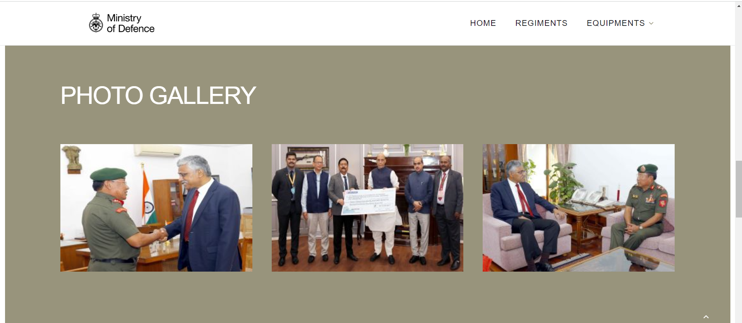

* REGIMENT

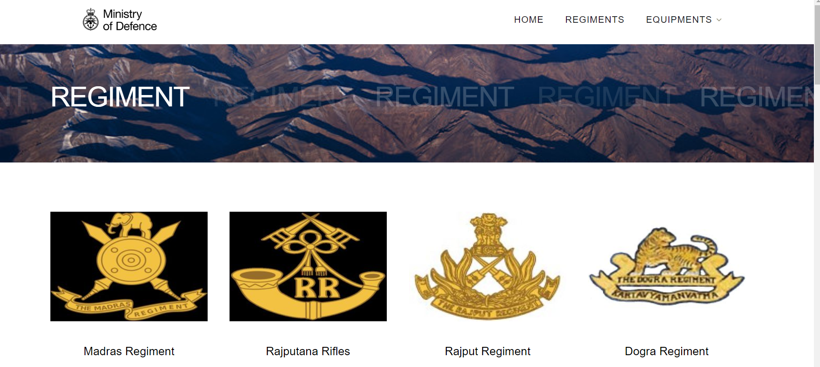



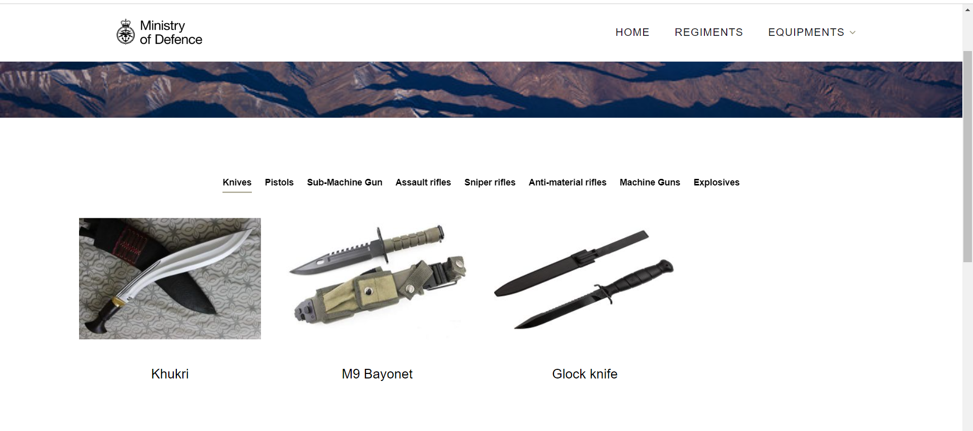

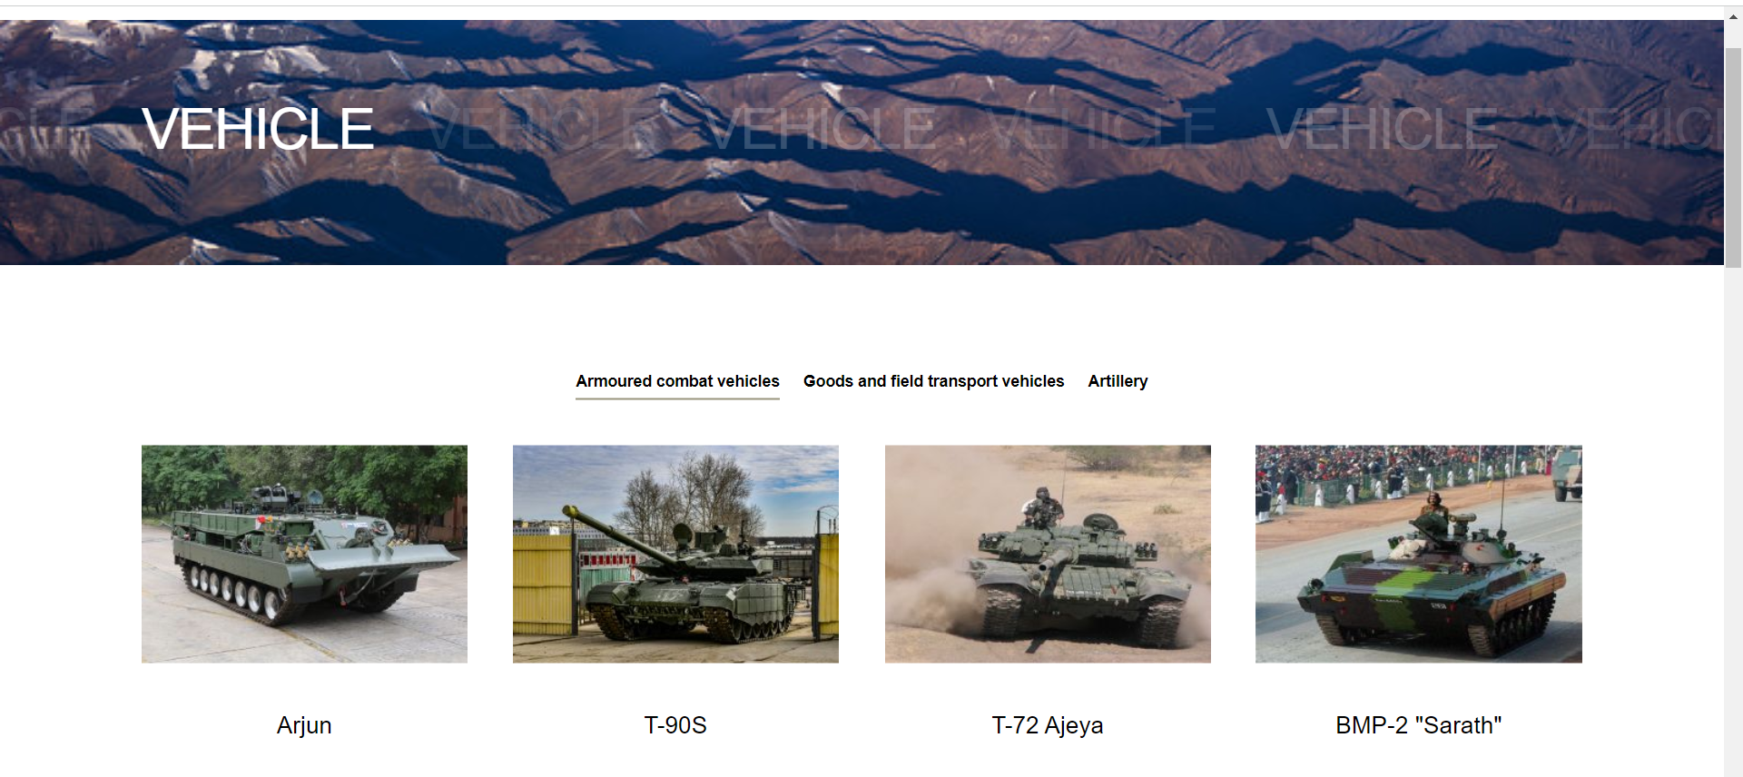

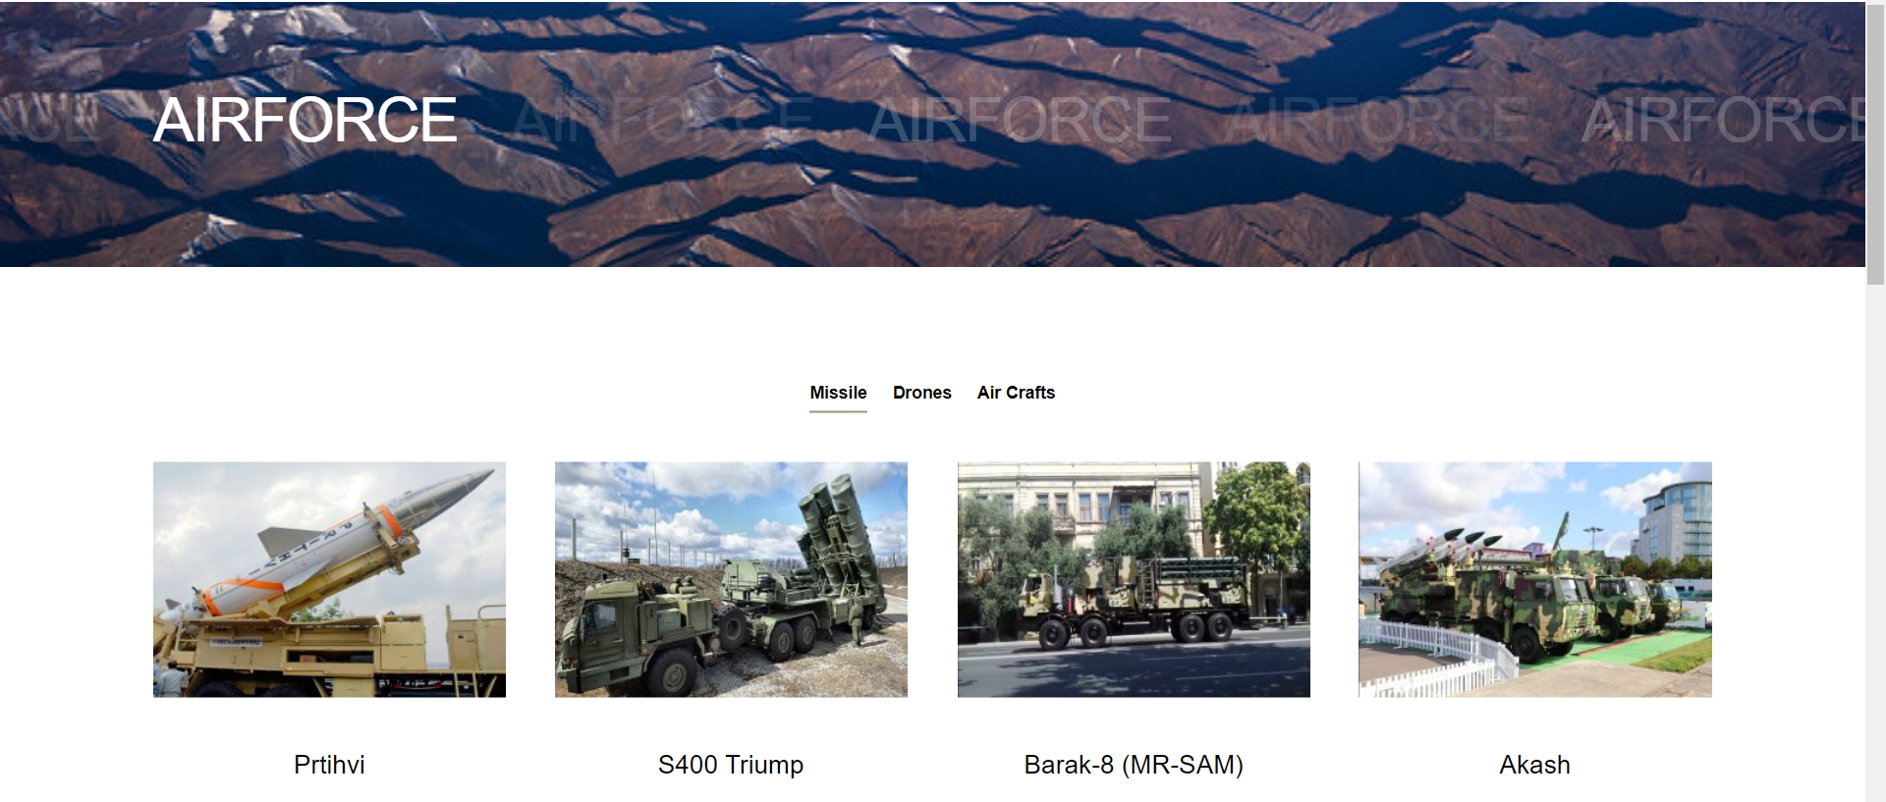

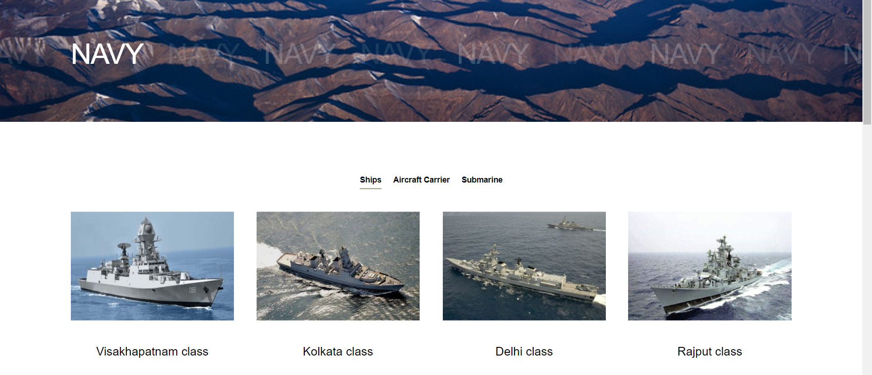

* Admin side:

